COGNIZANT WEEK 2 SOLUTIONS
BHUMISTHA SAHOO

Exercise 2: E-commerce Platform Search Function
Project Description
The E-commerce Platform Search Function project demonstrates the implementation and analysis of two fundamental searching algorithms: Linear Search and Binary Search. The application simulates an e-commerce platform where users can search for products using their product ID. Products are stored in an array for linear search and in a sorted array for binary search. The project compares the performance and time complexity of both algorithms to determine the most efficient approach for handling product searches in large-scale applications.

Project Structure
EcommerceSearchExample
│
├── Product.java
├── LinearSearch.java
├── BinarySearch.java
└── SearchTest.java

Product.java
public class Product {
int productId;
String productName;
String category;
public Product(int productId, String productName, String category) {
this.productId = productId;
this.productName = productName;
this.category = category;
}
public void display() {
System.out.println(productId + " " + productName + " " + category);
}
}

LinearSearch.java
public class LinearSearch {
public static Product search(Product[] products, int id) {
for (Product product : products) {
if (product.productId == id) {
return product;
}
}
return null;
}
}

BinarySearch.java
public class BinarySearch {
public static Product search(Product[] products, int id) {
int left = 0;
int right = products.length - 1;
while (left <= right) {
int mid = (left + right) / 2;
if (products[mid].productId == id) {
return products[mid];
}
if (products[mid].productId < id) {
left = mid + 1;
} else {
right = mid - 1;
}
}
return null;
}
}

SearchTest.java
import java.util.Arrays;
import java.util.Comparator;
public class SearchTest {
public static void main(String[] args) {
Product[] products = {
new Product(105, "Laptop", "Electronics"),
new Product(101, "Shoes", "Fashion"),
new Product(103, "Phone", "Electronics"),
new Product(102, "Watch", "Accessories"),
new Product(104, "Bag", "Fashion")
};
System.out.println("Linear Search");
Product result1 = LinearSearch.search(products, 103);
if (result1 != null) {
result1.display();
} else {
System.out.println("Product Not Found");
}
Arrays.sort(products, Comparator.comparingInt(p -> p.productId));
System.out.println();
System.out.println("Binary Search");
Product result2 = BinarySearch.search(products, 103);
if (result2 != null) {
result2.display();
} else {
System.out.println("Product Not Found");
}
}
}

Output
Linear Search
103 Phone Electronics
Binary Search
103 Phone Electronics
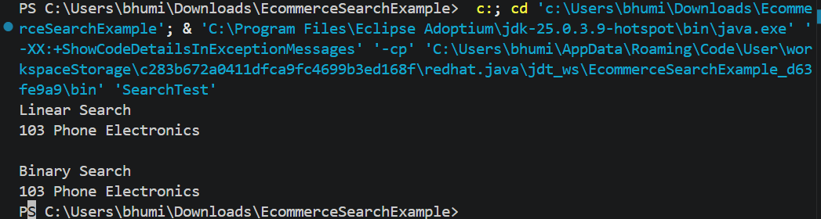

Analysis
Big O Notation:
Big O notation measures the efficiency of an algorithm by describing how its execution time grows as the input size increases.
Best Case:
Linear Search: O(1)
Binary Search: O(1)
Average Case:
Linear Search: O(n)
Binary Search: O(log n)
Worst Case:
Linear Search: O(n)
Binary Search: O(log n)
Time Complexity Comparison
Algorithm Best Average Worst
Linear Search O(1) O(n) O(n)
Binary Search O(1) O(log n) O(log n)
Conclusion:
Binary Search is more suitable for an e-commerce platform because it performs much faster on large datasets. It reduces the number of comparisons and provides O(log n) time complexity when the data is sorted. Linear Search is better suited only for small or unsorted datasets.

Exercise 7: Financial Forecasting

Project Description
This project demonstrates a simple financial forecasting tool using recursion. The program predicts the future value of an investment based on a fixed annual growth rate. It illustrates the concept of recursion, analyzes its time complexity, and discusses possible optimizations to improve performance.

Project Structure
FinancialForecasting
│
├── FinancialForecast.java
└── ForecastTest.java

FinancialForecast.java
public class FinancialForecast {
public static double futureValue(double currentValue, double growthRate, int years) {
if (years == 0) {
return currentValue;
}
return futureValue(currentValue, growthRate, years - 1) * (1 + growthRate);
}
}

ForecastTest.java
public class ForecastTest {
public static void main(String[] args) {
double currentValue = 10000;
double growthRate = 0.10;
int years = 5;
double result = FinancialForecast.futureValue(currentValue, growthRate, years);
System.out.printf("Future Value after %d years = %.2f", years, result);
}
}

Output
Future Value after 5 years = 16105.10
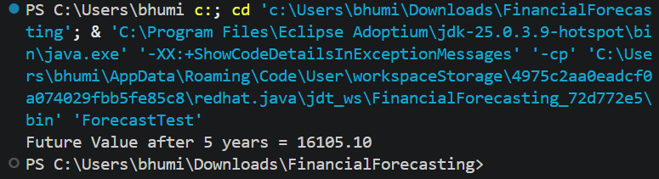

Analysis
Recursion is a technique in which a method calls itself to solve a smaller version of the same problem. It simplifies problems that can be broken down into repetitive subproblems.
Time Complexity:
• Recursive Algorithm: O(n), where n is the number of years.
• Space Complexity: O(n) due to the recursive call stack.
Optimization:
• Use an iterative loop to eliminate recursion overhead.
• Apply memoization when recursive calls repeat the same subproblems.
• For this example, iteration is the most efficient approach because there are no overlapping subproblems.

